EOC Unit 15: Engineering Design Process and unbiased experiments

- Engineering design process:

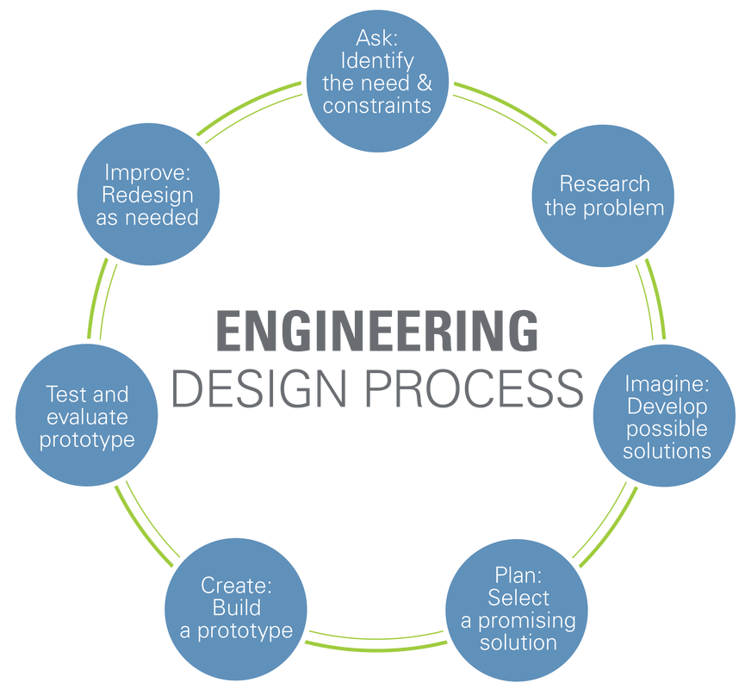

- Unbiased recording
- Anonymous evaluation
- Repeatable results
- Several trials by uninterested parties

