Unit 11 EOC: solubility

- Solubility: define and give an example using sodium chloride and water
- Mixture: including the terms solute and solvent, define mixture
- Solubility chart: Copy the following solubility chart into your notebook (may cut this one out and tape into notebook)
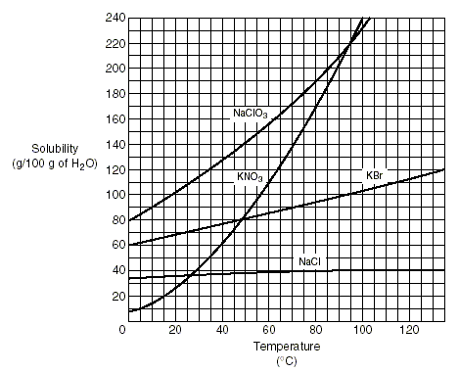
  - Answer the following questions about the solubility chart: (copy the questions in your notebook as well as answers)

- At 40ºC why would 50 grams of KNO₃ produce an unsaturated solution, but 38 grams of sodium chloride would produce a saturated solution.
- Define a supersaturated solution. Using the graph above, give an example of a supersaturated solution.

