EOC Concept Notebook
Purpose and Grading
- Create an ongoing comprehensive study guide for the EOC standards
- Directions will be followed explicitly, to that end, the grade will be all or nothing.
- Due: the day of the unit test to which they were assigned
- Mandatory: If not turned in the day of the unit exam, or turned in incomplete, a zero grade will be given; however you will still be require to come in during directed study time to complete

Explicit Instruction:
- Top of first page will be titled: Unit ____ EOC concepts
- You will start on left side of paper with number and concept, sufficient space will be left between concept and discussion of concept, then discussion of concept
- You will be asked define, compare, calculate, summarize different standards. Here are direction for how to correctly complete those standards:
- Examples and non-examples must contain a brief justification or explanation of why your example follows the definition and non-example does not follow definition.
- Summaries must be put in chart or separate columns with headings
- If math involved, show how the math is done (self-tutorial)
- Comparisons: bulleted side by side
- Particulate level drawing: accurately depict size, motion, arrangement of applicable particles.
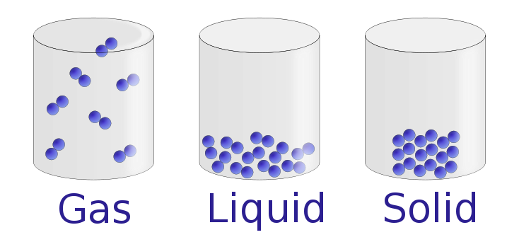
This would show, at the particulate level, the difference in arrangement of molecules in the solid, liquid, and gaseous state

We will complete Unit 1 standards together in class to give you a template to follow for the rest of the year.
Unit I:
- Matter: definition, example, non-example
- Atom: definition
- Element: definition, example, non-example
- Property: definition and example
- Summary of Models: chart with scientist, name of model, feature of model, experiment associated with model (Dalton, Thomson, Rutherford)
- Summary of subatomic particles: chart with particle, location in atom, charge, and mass (proton, neutron, electron)
- Atomic number: information atomic number gives you example of a square on the PT
- Mass number: definition example
- Isotope: definition, give an example including both notations (hyphen and nuclear)
- Average atomic mass: definition, example using an element with multiple isotopes

