Acids and Bases homework 2
- List six properties of acids
- Using the reactivity of metals chart, determine which of the following metals would react with hydrochloric acid, and write the balanced equation for the reaction
Zn, Pt, Ag, Li
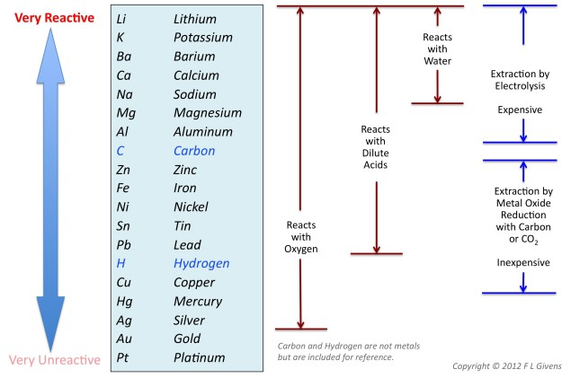

- List five properties of bases
- State the Arrhenius theory of acids and bases. Write an equation showing an example of a compound that is an Arrhenius acids and a compound that is an Arrhenius base
- Discuss ionization acid and dissociation of a base. Show at the particulate level an acid reacting with water and a base reacting with water
- Discuss the difference between weak and strong acids and bases. Relate this to conductivity of the solution
- Give the name and formula of the 6 strong acids and 7 strong bases

